**Application setup**

1. First create new database name as "ThinkBridge"
2. Open application in the visual studio and click solution explorer
3. select ThinkBridge and right click in the popup window click schema compare

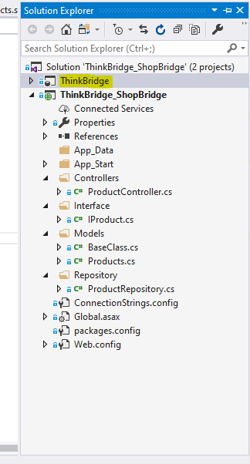

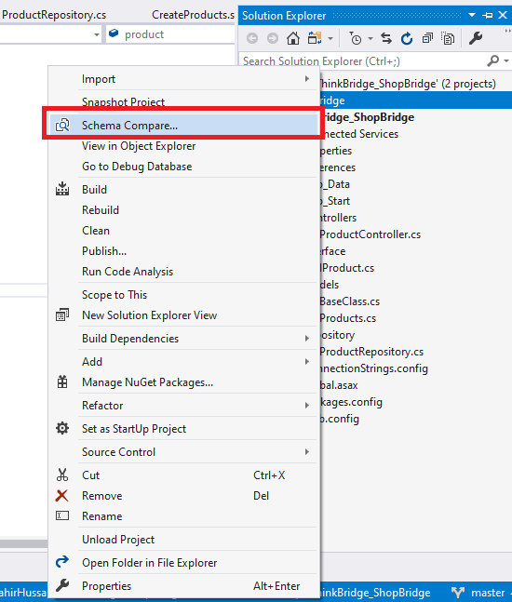

1. Compare your database with application DB

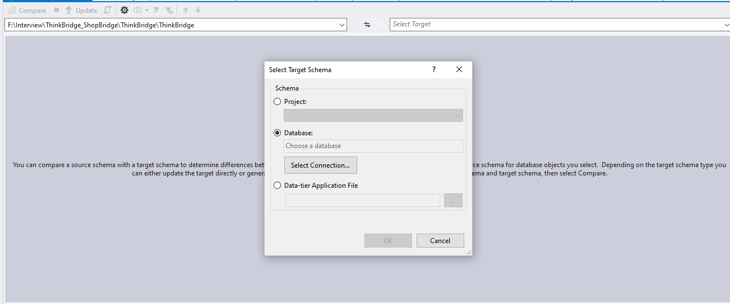

Select your database

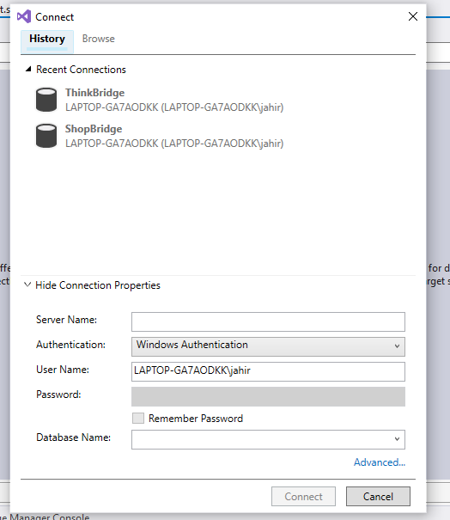

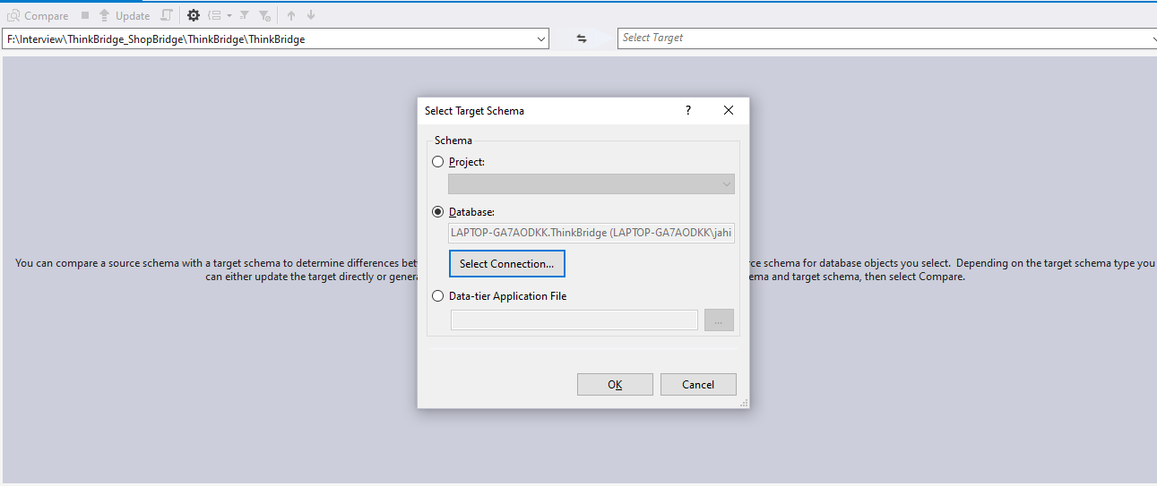

Click OK and click compare

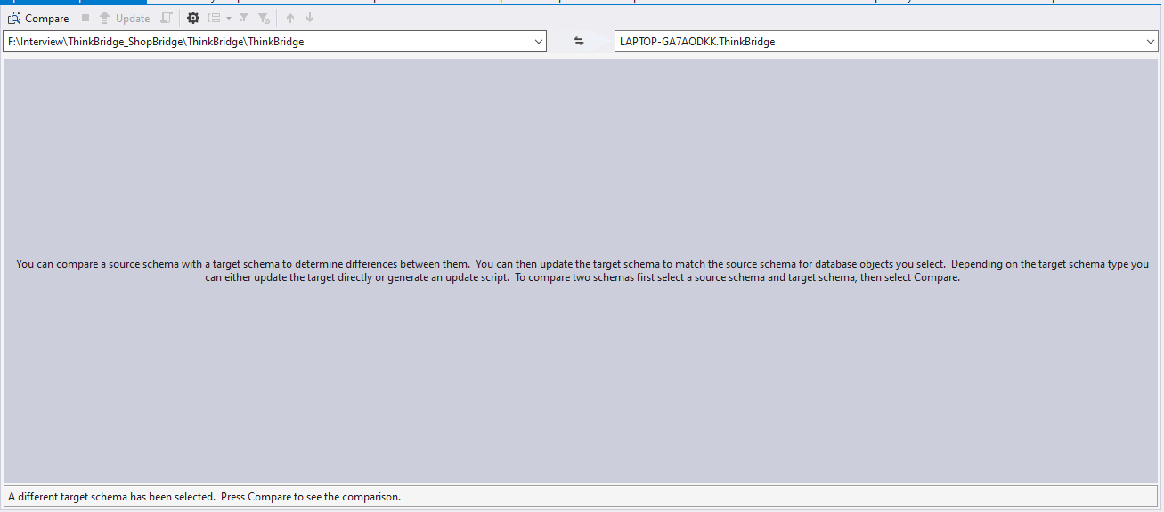

After comparison it will show all the difference and click update

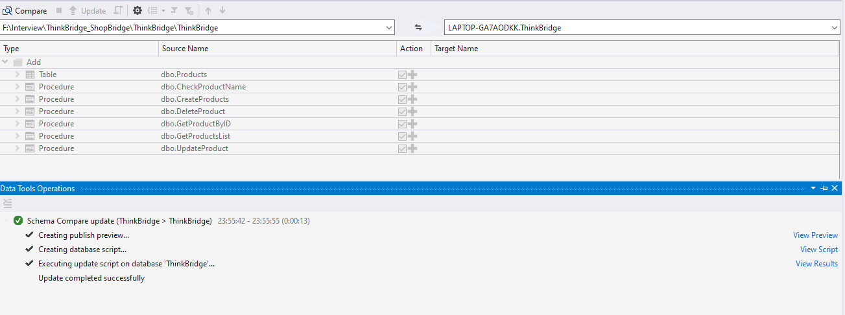

All DB migration completed.